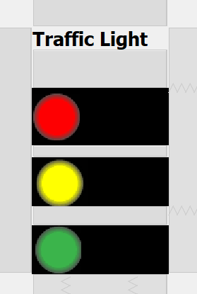

import java.awt.event.ActionEvent;
import java.awt.event.ActionListener;
import javax.swing.Timer;

public class Light extends javax.swing.JFrame { //Agamya
private final int nRed=10;
private final int nYellow=3;
private final int nGreen=10;
private int r,y,g;
private Timer timer;

public Light() {
initComponents();
red.setEnabled(true); //Agamya
green.setEnabled(false);
yellow.setEnabled(false);
start();
}
private void start(){
int speed=1000; // 1 second // Agamya

r =nRed;
y =nYellow;
g = nGreen;

ActionListener action =new ActionListener(){
public void actionPerformed(ActionEvent evt){
if(r>=0){
red.setText(String.valueOf(r));
r--;

}else if(y>=0){
yellow.setText(String.valueOf(y));
y--;
red.setText(null);
red.setEnabled(false);
yellow.setEnabled(true);
}else if(g>=0){
green.setText(String.valueOf(g));
g--;
yellow.setText(null);
yellow.setEnabled(false);
green.setEnabled(true);
}else
{

red.setEnabled(true);
green.setEnabled(false);
yellow.setEnabled(false);
green.setText(null);
r =nRed;
y =nYellow;
g = nGreen;

}
}
};
timer=new Timer(speed, action);
timer.start();

}

public static void main(String args[]) {
java.awt.EventQueue.invokeLater(new Runnable() {
public void run() {
new Light().setVisible(true);
}
});
}
private javax.swing.JLabel green;
private javax.swing.JLabel jLabel1;
private javax.swing.JLabel red;
private javax.swing.JLabel yellow;
// End of variables declaration
}

